App Service overview

🌐 What is App Service?

App Service is a cloud-based platform from Microsoft Azure that lets you build, host, and manage web apps, REST APIs, and mobile back-ends quickly—without managing any physical infrastructure.

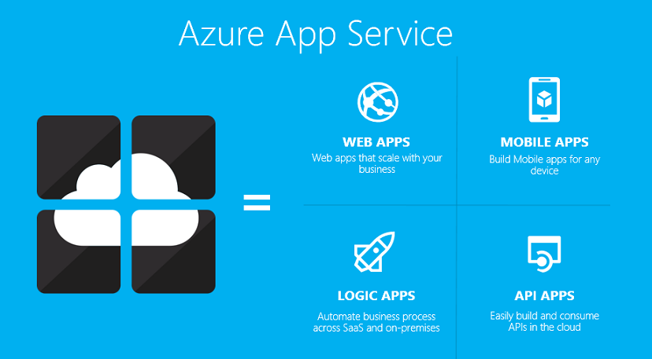

📦 Simple Example:
Imagine you created a small website using HTML and .NET where users can view your bakery's menu and order cakes.
Without App Service, you’d need to:
- Buy a server or hosting space
- Set it up, manage security, and monitor usage
But with App Service, you:
- Upload your code to Azure
- Azure runs your site for you (24/7)
- If more people visit your site, it automatically scales to handle traffic
- You can even update your site easily using GitHub or Visual Studio
⚙️ How App Service Works
- You create your web app using any language like .NET, Java, or Python.
- You deploy your app to Azure App Service from GitHub, Visual Studio, or ZIP upload.
- Azure hosts your app and gives it a public URL to access online.
- It automatically scales and manages resources based on user traffic.
- You monitor and update the app easily without worrying about the underlying servers.
🎂 Example:
Let’s say you have a Cake Order Website:
- You write it in ASP.NET
- Upload it to Azure App Service
- Azure hosts it, keeps it running 24/7, and lets customers order anytime
- If 10 or 10,000 people visit — Azure adjusts automatically

🚀 Why use App Service?

- Easy Deployment: You can deploy your app directly from Visual Studio, GitHub, or Azure DevOps.
- Scalable: It automatically handles scaling to support more users as your app grows.
- Secure: It supports custom domains, HTTPS, authentication (Google, Facebook, etc.), and compliance standards.
- Supports Multiple Languages: Works with .NET, Java, PHP, Node.js, Python, etc.

🔧 Common Use Cases
- Hosting websites or web apps (like company portals or e-commerce)
- Creating backend services for mobile apps
- Running scheduled jobs or background tasks

⭐ Key Features (Simple):
Supports Multiple Languages
Run apps built with .NET, Java, Python, Node.js, PHP, etc.
Easy Deployment
Deploy directly from Visual Studio, GitHub, or ZIP files.
Auto Scaling
Automatically handles more users when traffic increases.
Custom Domain & HTTPS
Use your own website name with secure HTTPS connection.
Built-in Monitoring
Track app performance and errors using tools like Application Insights.
Staging Slots
Test updates in a separate slot before going live.
Secure and Compliant
Supports authentication (Google, Facebook, Microsoft) and meets global security standards.

